4.Creating custom filters for specific views

Using JIRA Query Language (JQL) for advanced searches

1. Board Search
2. Global
3. Basic
4. Advanced

project = "My Scrum Project" AND status = "In Progress"

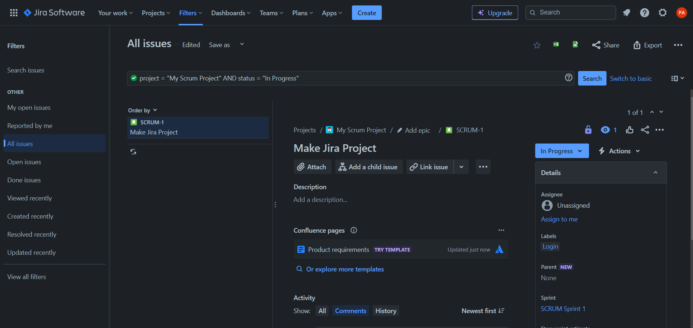

description IS EMPTY

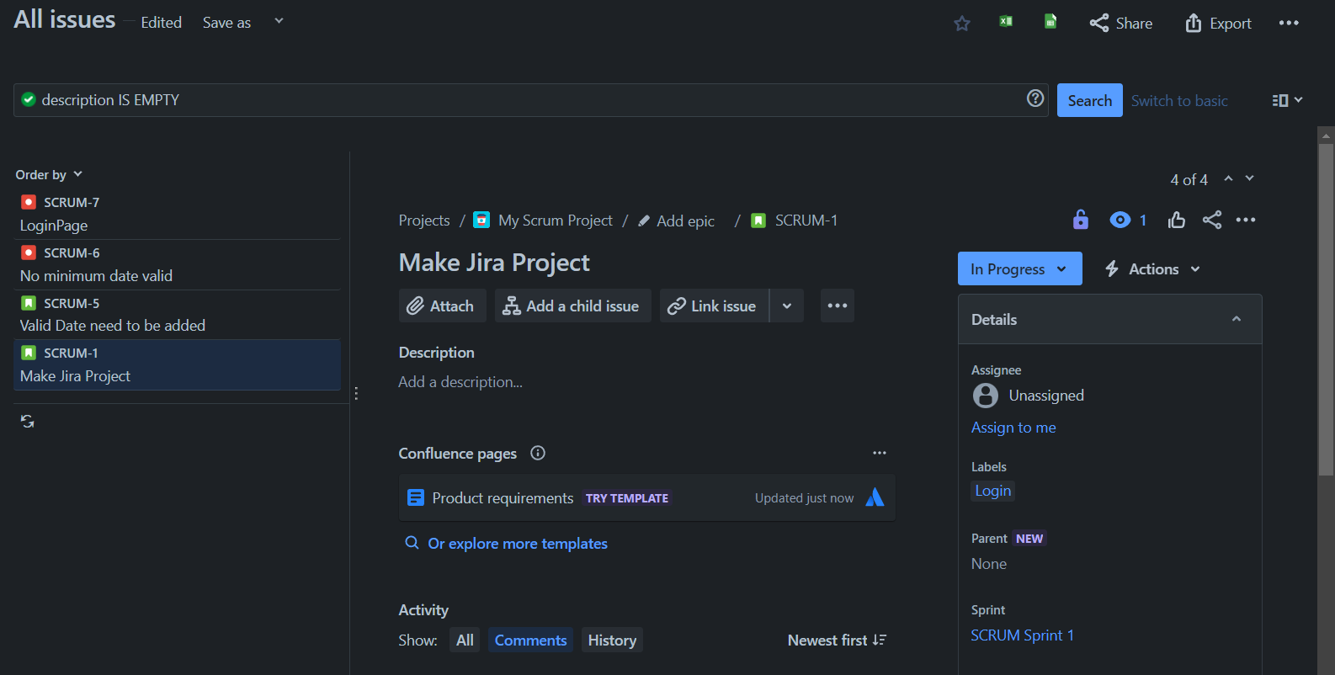

status != "To Do"

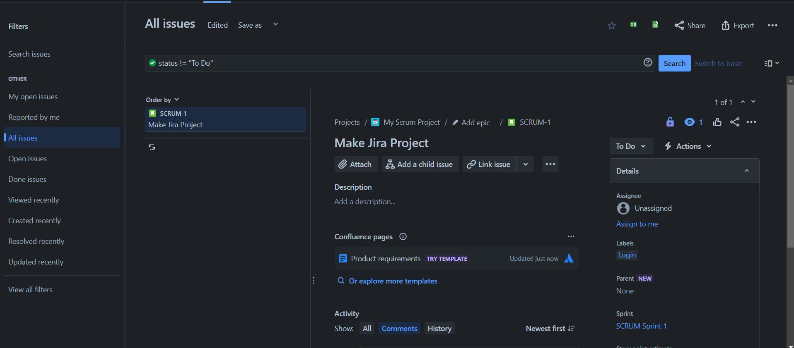

status IN ("To Do", "In Progress", "Closed")

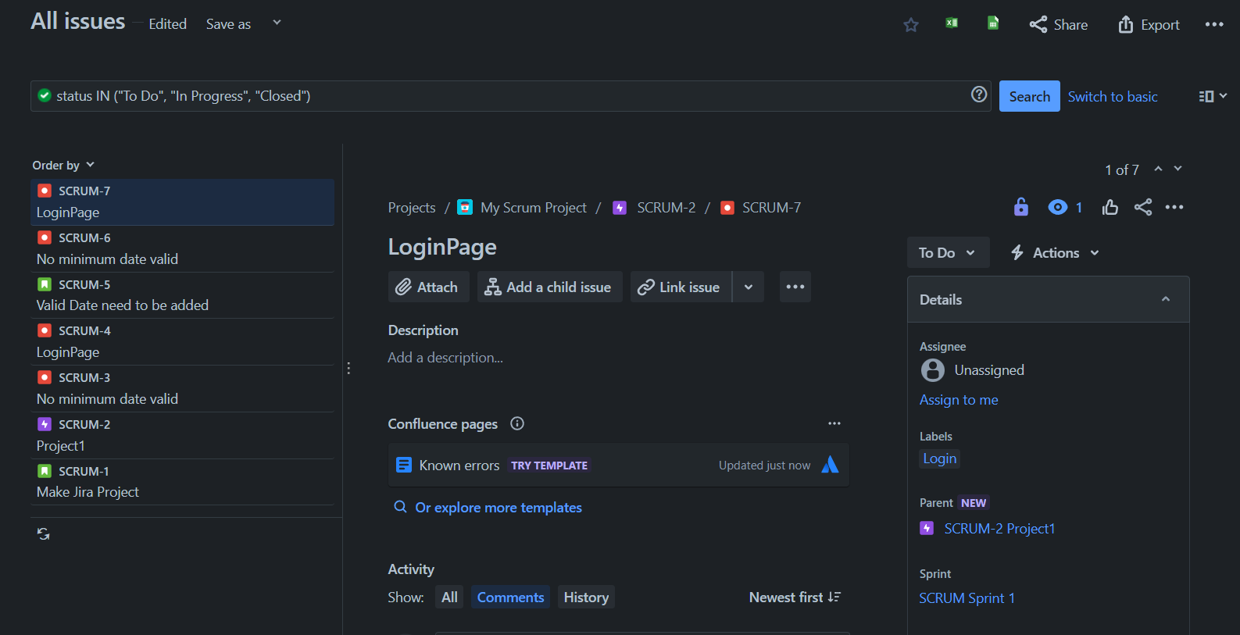

reporter = "Pooja Ahuja" AND project = "My Scrum Project"

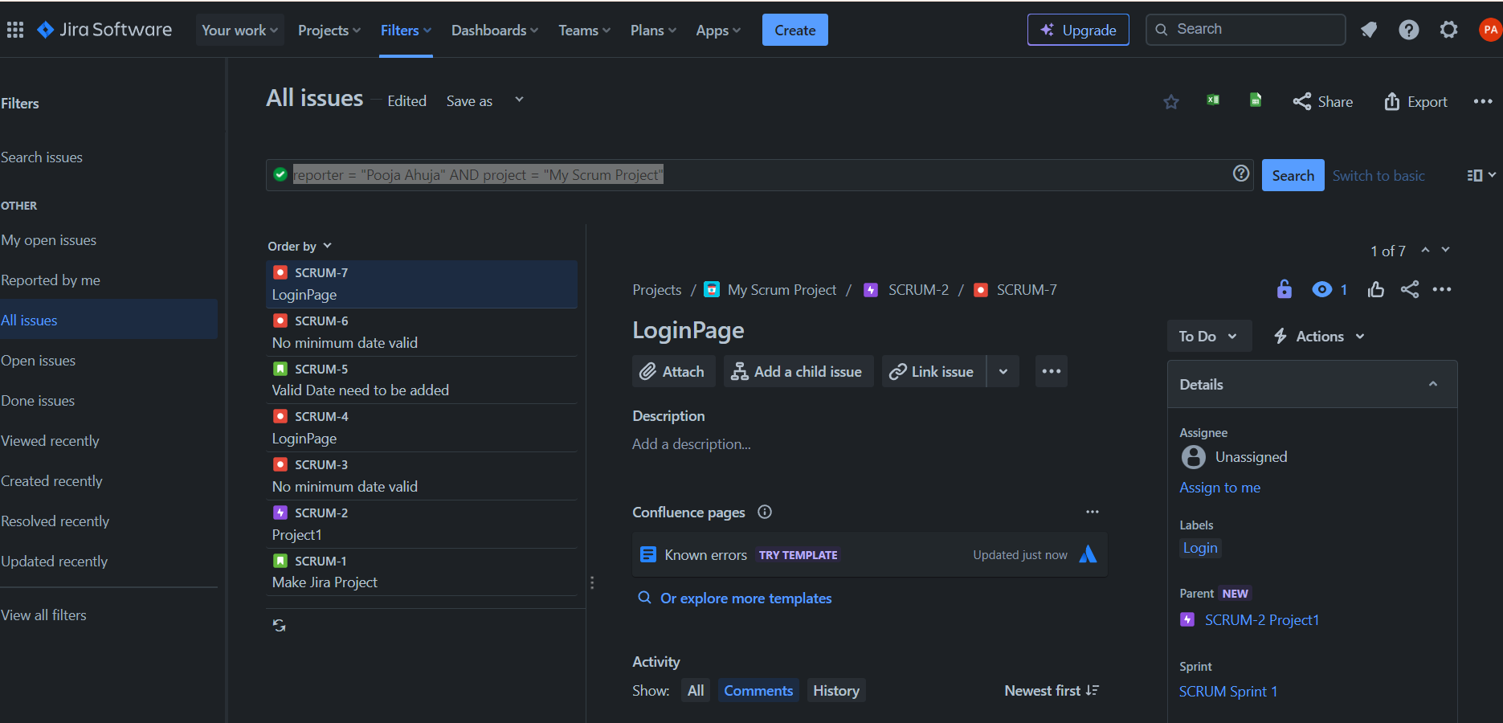

assignee is EMPTY and created < -1d

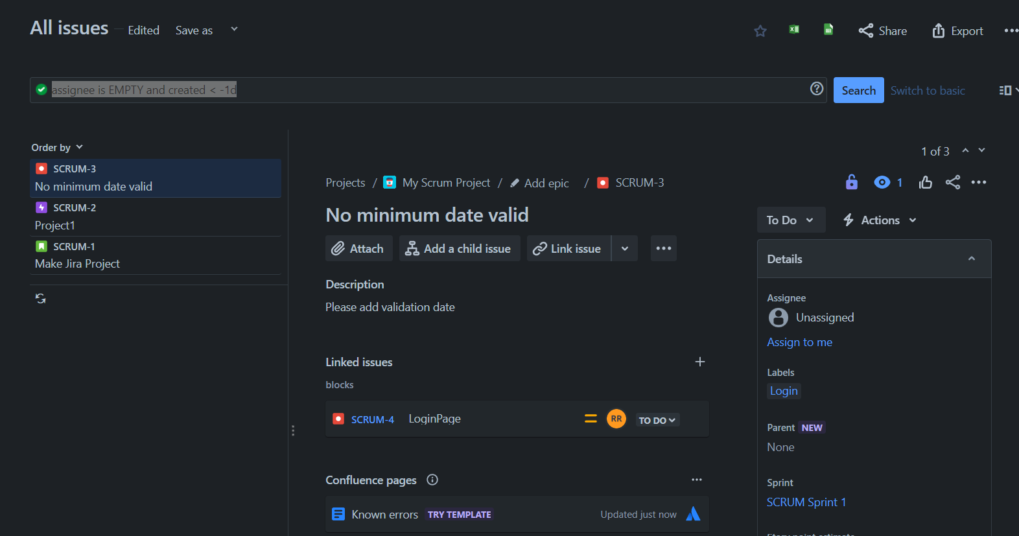

5.Creating personalized dashboards

Generating and interpreting various reports

In the board page click on the dashboard and then click on create dashboard give the name for the dashboard

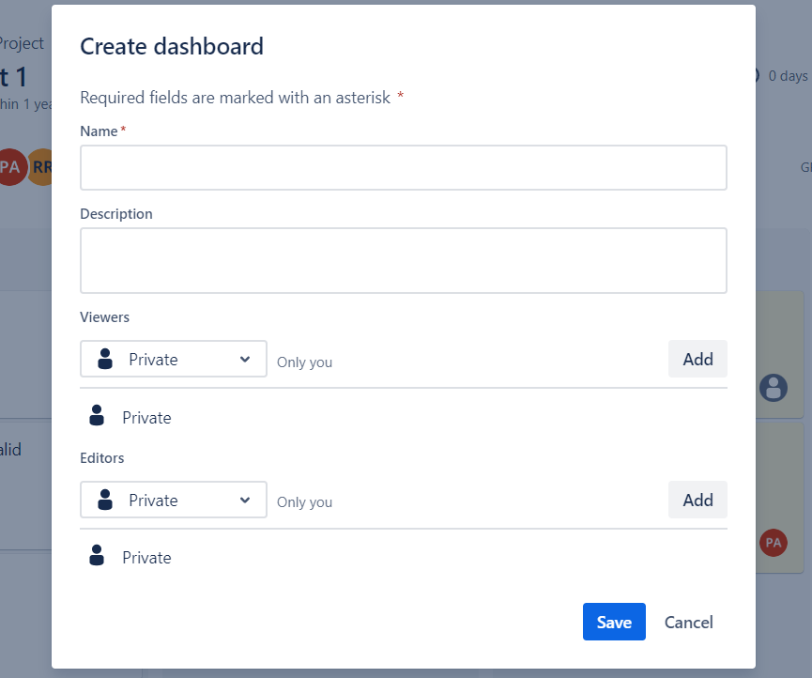

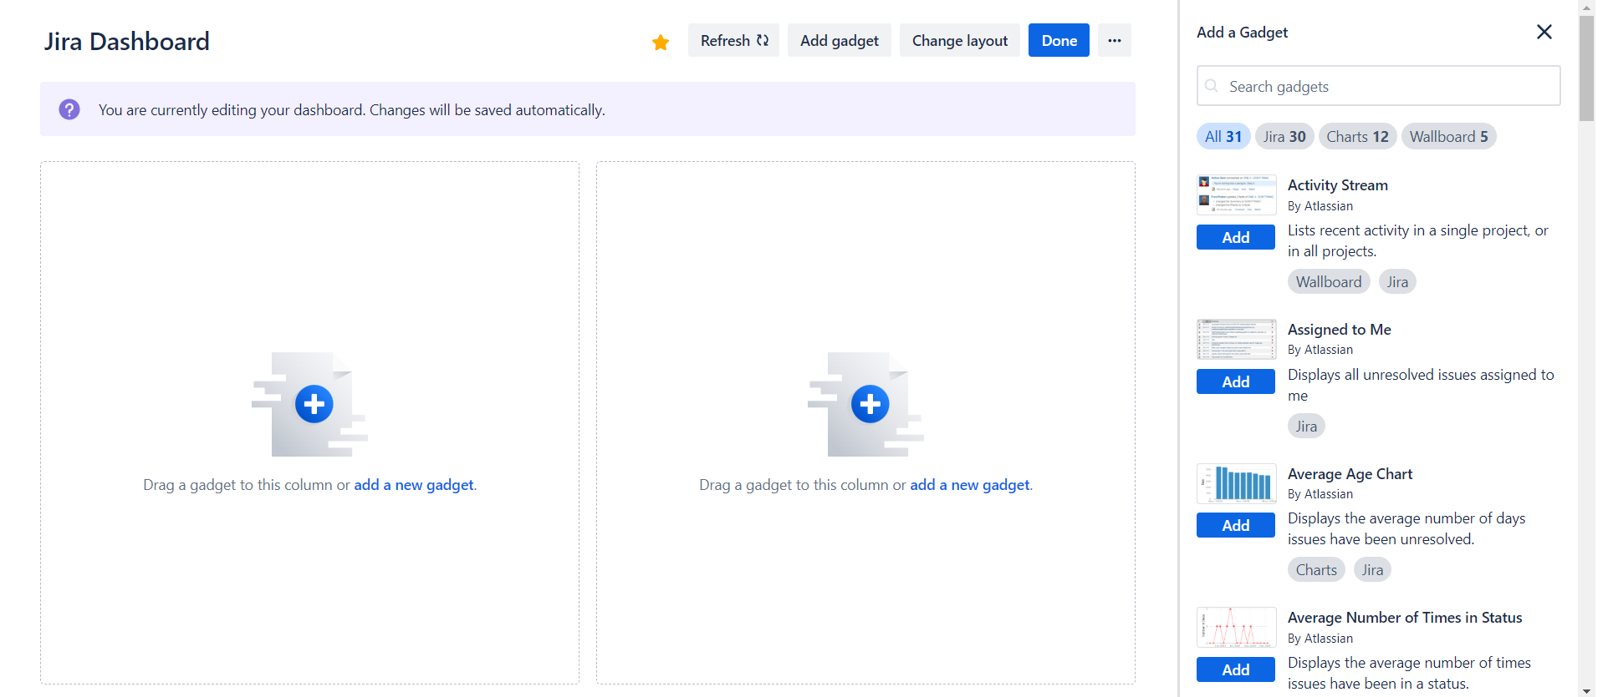

Click on the new gadget and select any of the chart you want and display the respective chart(Velocity chart has be shown in the lab)



